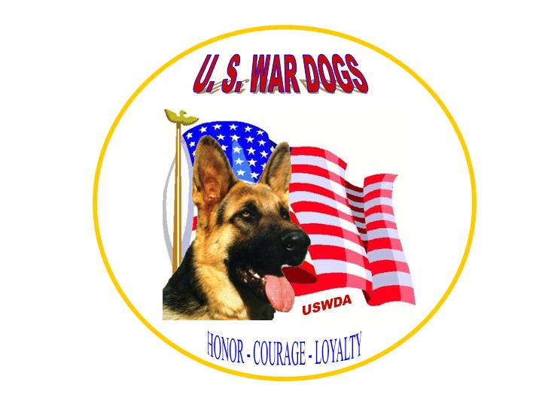

K-9 Heroes, A Veteran
by barbara snow

How many more names would be on that Wall?
Were it not for you – you heeded our country's call
You served and you bled thru all our war years
Many of you died with only a handler's tears
Your duties are many, you scent and you track
Your eyes tell me always, "I've got your back"
You rescue and save lives and when that’s in vain
You recover to bring closure to a family’s pain
You outsmart our enemies – it's you that they fear
You warn me when mines and explosives are near
You guard our beaches and borders and our Commander-in-Chief
Words “Stop, or I’ll release my dog” mean it’s over for a thief

Your eyes burned in Oklahoma City, your paws felt the flame
You brought me a small shoe – I moaned. “Oh God, No,” in pain
You comforted me for a moment; you nudged me on too
You knew we weren’t finished; we had more to do
You pull me to safety; you bring me a medic’s care
I open my eyes and know that you’re there
You have honor and spirit and feel our country’s pride
Sometimes in the night, only you knew I cried
I wish you had time to just run and play
Catch a Frisbee and swim – for a dog, a good day
But you are a Trooper, to duty you must
My life before yours - you give me that trust

No matter how clever an arsonist’s M. O.
Your nose tell investigators what they need to know
Some call you Coastie, you get “Semper Fi’’
The chute makes you perk – you love when we fly
As an Officer and Deputy, it’s crime that you fight
You wear the badge of the elite – “Guardians of the Night”
The love of a mascot knows no race, class or ranks
Privates, Admirals, Generals all give you their thanks
When you outlive me and Taps reaches your ears
You stand there with honor among bagpipes and tears

When your bones become old and you no longer serve
It’s medical care in retirement you earned and deserve.
Congress could pass a law to resolve this need
For all serving and in memory, for them I now plead
We must call you ‘Veteran’ for you are one too
No honor for me, if there is none for you
Till death do us part, this mantra rings true
They gave and give all for the Red White and Blue.

www.uswardogs.org - Southern Chapter P.O. Box 10Bronson, FL 32621 k9mwds@gmail.com www.k9wardogadvocates.com www.uswardogs.org

